Experiment Number : 8 Date: 25.02.2026

Implementation of Packages in Java

Aim:
Write a Java program to implement built-in, user-defined packages and accessing all classes in a package.

PRE LAB EXERCISE
QUESTIONS
- What is java.util package and what collection framework does it contain?
java.util package:
- It is a predefined package in Java that provides utility classes.
- It contains classes for data structures, date & time, random numbers, and string handling.
- It helps in storing and manipulating groups of objects.
- It is imported using import java.util.*;.
Collection Framework in java.util:
- Interfaces – List, Set, Queue, Map.
- Classes – ArrayList, LinkedList, HashSet, TreeSet, HashMap, etc.
- Iterator – Used to traverse collection elements.
- Collections class – Provides methods for sorting and searching.

- What are the two types of packages in Java?
Built-in (Predefined) package
- Packages that are already available in Java API.
- No need for user creation.
- Directly imported using the import keyword.
- Example: java.lang, java.util, java.io.
User-defined package
- Package created by the programmer.
- Declared using the package keyword.
- Used to group related classes and interfaces.
- Helps to avoid name conflicts and improves reusability.

IN LAB EXERCISE
Objective
To understand and implement the concepts of built-in, user-defined packages and accessing all classes in a package in Java.
Built-in Packages comprise a large number of classes that are part of the Java API. Some of the commonly used built-in packages are:
- java.lang: Contains language support classes(e.g, classes that define primitive data types, math operations). This package is automatically imported.
- java.io: Contains classes for supporting input/output operations.
- java.util: Contains utility classes that implement data structures such as Linked Lists and Dictionaries, as well as support for date and time operations.
- java.applet: Contains classes for creating Applets.
- java.awt: Contains classes for implementing the components for graphical user interfaces (like buttons, menus, etc).
Source Code
import java.util.Random; // built-in package
public class Sample{
public static void main(String[] args) {
// using Random class
Random rand = new Random();
// generates a number between 0–99
int number = rand.nextInt(100);
System.out.println("Random number: " + number);
}
}
Output
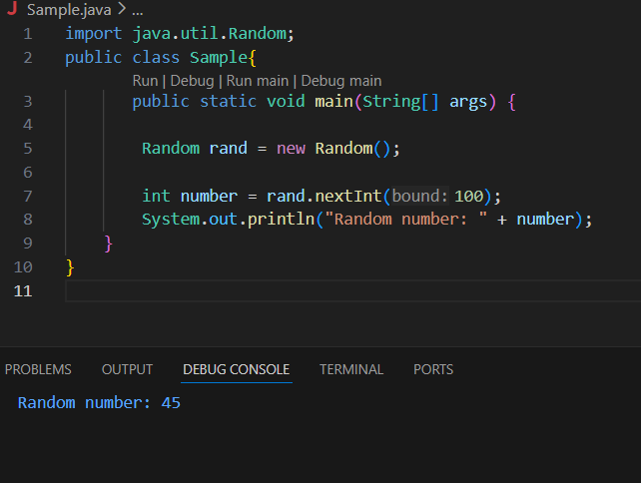
User-defined Packages are the packages that are defined by the user.
Source code
package com.myapp;
public class Helper {
public static void show() {
System.out.println("Hello from Helper!");
}
}
==To use this in another class==
import com.myapp.Helper;
public class Test {
public static void main(String[] args) {
Helper.show();
}
}

Output:
Hello from Helper!
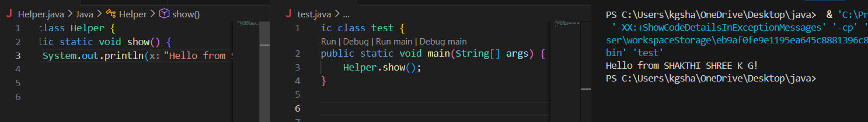
Source code
import java.util.Vector;
public class Coders {
public Coders() {

Vector v = new Vector();
java.util.ArrayList l = new java.util.ArrayList();
l.add(2);
l.add(5);
l.add(8);
System.out.println(l);
}
public static void main(String[] args) {
new Coders();
}
}
Output
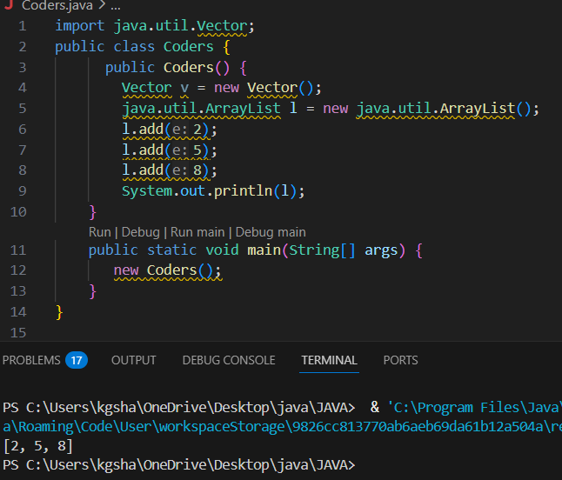
POST LAB EXERCISE
- What will happen if two classes in different packages have the same name and are imported in a Java file?
- It creates a name conflict (ambiguity).
- The compiler cannot identify which class to use.
- This results in a compile-time error.
- To solve it, use the fully qualified class name (package name + class name).

- What is the purpose of using packages in Java?
- To organize related classes and interfaces into a single unit.
- To avoid naming conflicts.
- To provide access protection (security).
- To support code reusability and easy maintenance.

- Which built-in Java package would you use if you want to create a GUI window and display a message?
- java.util
- java.sql
- java.awt
- java.net
Correct Answer: C. java.awt
- It is used for creating GUI applications.
- Provides components like Frame, Button, Label.
- Used for window-based applications.
- Handles graphics, layout, and events.

ASSESSMENT

Description | Max Marks | Marks Awarded
Pre Lab Exercise | 5
In Lab Exercise | 10
Post Lab Exercise | 5
Viva | 10
Total | 30
Faculty Signature

Experiment Number : 9 Date: 25.02.2026

Implementation of a Java Program to import packages using different methods

Aim:
Write a Java program to import packages using different methods for different use cases.

PRE LAB EXERCISE
QUESTIONS
- How to import a single class and multiple classes from a package in Java?
• A single class can be imported using import package_name.ClassName;
• Example: import java.util.Scanner;
• All classes in a package can be imported using import package_name. *;
• Example: import java.util.*.

- Which package is always imported by default in every Java class?
• java.lang is automatically imported in every Java program
• It provides fundamental classes required for program execution
• It contains classes like String, System, Math, and wrapper classes
• No explicit import statement is needed for this package

IN LAB EXERCISE
Objective
To understand and implement the Java packages using different methods and import them.
Problem
Define a package named ‘useFul’ with a class names ‘UseMe’ having following methods:
1) area ()- To calculate the area of given shape.
2) salary ()- To calculate the salary given basic Salary,da,hRA.
3) percentage ()-To calculate the percentage given total marks and marks obtained.
4) Develop a program named ‘Package Use’ to import the above package ‘useFul’ and use the method area ().
5) Develop a program named ‘manager’
Source Code
//Package Creation:
package useFull;
import java.util.*;

public class UseMe {

Scanner obj = new Scanner(System.in);

// ----------- AREA METHOD -----------
public void area() {

class Method {

void aos(int a) {
System.out.println("\nArea of square with length " + a + " is " + (a * a));
}

void aor(int a, int b) {
System.out.println("\nArea of rectangle with dimensions " + a + " & " + b + " is " + (a * b));
}

void aoc(int r) {
double a = 3.14 * r * r;
System.out.println("\nArea of circle with radius " + r + " is " + a);
}

void aot(int a, int b) {
float ar = (a * b) / 2.0f;
System.out.println("\nArea of triangle with dimensions " + a + " & " + b + " is " + ar);
}
}

Method m = new Method();

System.out.println("\n1.Square\n2.Rectangle\n3.Circle\n4.Triangle\nSelect the shape");
int ch = obj.nextInt();

switch (ch) {

case 1:
System.out.print("\nEnter the length of side of square : ");
int s = obj.nextInt();
m.aos(s);
break;

case 2:
System.out.print("\nEnter the dimensions of rectangle : ");
int l = obj.nextInt();
int b = obj.nextInt();
m.aor(l, b);
break;

case 3:
System.out.print("\nEnter the radius of circle : ");
int r = obj.nextInt();
m.aoc(r);
break;

case 4:
System.out.print("\nEnter the dimensions of triangle : ");
int ba = obj.nextInt();
int w = obj.nextInt();
m.aot(ba, w);
break;

default:
System.out.println("Invalid choice");
}
}

// ----------- SALARY METHOD -----------
public void salary() {

int ba, da, hra;

System.out.print("\nEnter the basic salary : ");
ba = obj.nextInt();

System.out.print("\nEnter the dearness allowance : ");
da = obj.nextInt();

System.out.print("\nEnter the house rent allowance : ");
hra = obj.nextInt();

System.out.println("\nThe total Gross salary of employee is : " + (ba + da + hra));
}

// ----------- PERCENTAGE METHOD -----------
public void percentage() {

int n, sum = 0;
float p;

System.out.print("\nEnter the total number of subjects : ");
n = obj.nextInt();

int m[] = new int[n];

System.out.print("\nEnter the marks of " + n + " subjects : ");

for (int i = 0; i < n; i++) {
m[i] = obj.nextInt();
sum += m[i];
}

p = (float) sum / n;

System.out.println("\nPercentage of student : " + p);
}

// ----------- CLOSE SCANNER -----------
public void close() {
obj.close();
}
}
//Package Implementation-1:
import useFull.UseMe;
class packageUse
{
public static void main(String args[])
{
UseMe o=new UseMe();o.area();
}
}

Output
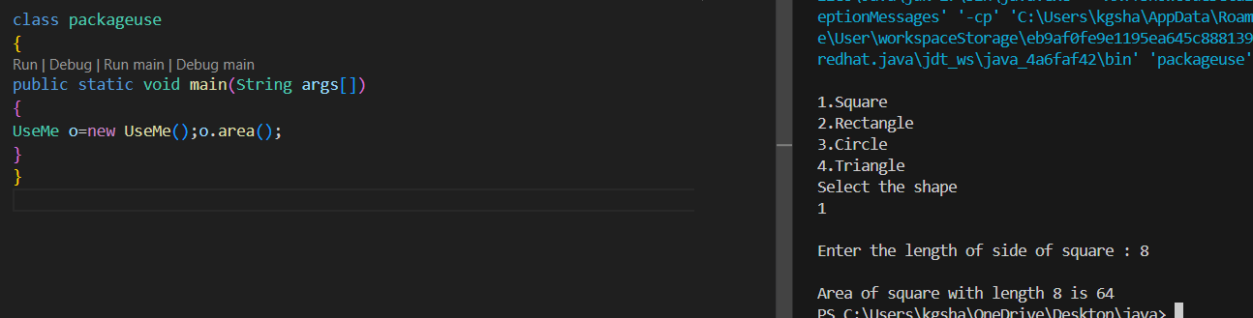//Package Implementation-2:
import useFull.UseMe;
class manager
{
public static void main(String args[])
{
UseMe obj=new UseMe();obj.salary();
}
}

Output
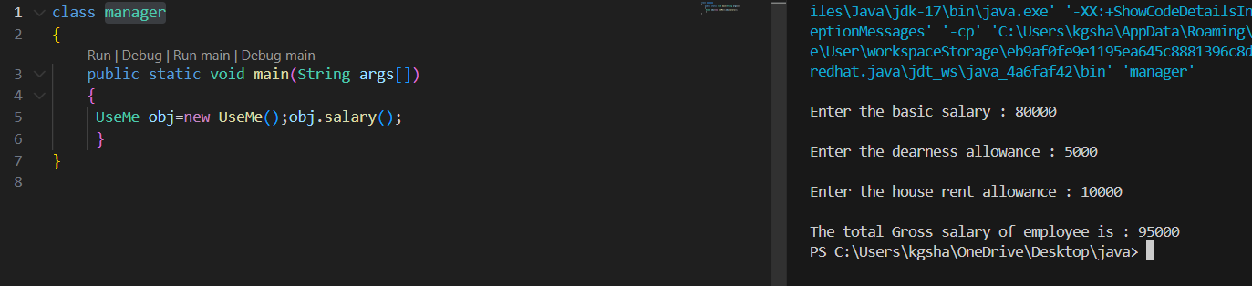
POST LAB EXERCISE
- Find the key differences between java.util and java.lang packages.
• java.lang is imported by default, whereas java.util must be imported explicitly
• java.lang contains core language classes, while java.util contains utility and collection classes
• java.lang includes String, System, Math, whereas java.util includes Scanner, Date, Random
• java.lang is used for basic operations, while java.util is mainly used for data handling and collections

- List some of the subpackages of java.util
java.util.concurrent
• Provides support for multithreading and concurrent programming
• Contains utilities like Executor framework and concurrent collections
java.util.regex
• Used for pattern matching with regular expressions
• Provides classes like Pattern and Matcher for string validation and searching
java.util.stream
• Processes data from collections using functional operations
• Supports sequential and parallel data processing
java.util.logging
• Used for logging application events and errors
• Provides different logging levels such as INFO, WARNING and SEVERE

ASSESSMENT

Description | Max Marks | Marks Awarded
Pre Lab Exercise | 5
In Lab Exercise | 10
Post Lab Exercise | 5
Viva | 10
Total | 30
Faculty Signature

Experiment Number : 10 Date: 26.02.2026

Implementation of Access Modifiers in Java

Aim:
Write a Java program to implement different access modifiers.

PRE LAB EXERCISE
QUESTIONS
- What are the 4 access modifiers available in Java?
The four access modifiers available in Java are:
- private → Accessible only within the same class
- default → Accessible within the same package
- protected → Accessible within the same package and by subclasses (even in different packages)
- public → Accessible from anywhere

- Which access modifiers can be used in Java to control access to class members?
Class members (variables, methods, constructors, inner classes) can use:
- Private
- Default
- Protected
- public
These modifiers control the visibility of the class members.

IN LAB EXERCISE
Objective
To demonstrate different access modifiers such as Default, Private, Protected and Public using Java programs.
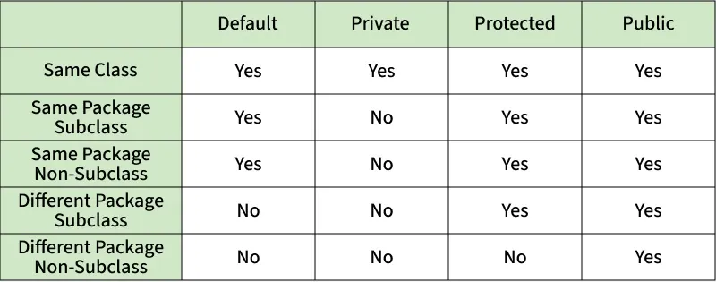
Fig: Comparison table of Access Modifiers in Java
Source Code
// Default Access modifier
class Car {
String model; // default access
}
public class Main {
public static void main(String[] args){
Car c = new Car();
c.model = "Tesla"; // accessible within the same package
System.out.println(c.model);
}
}
Output:
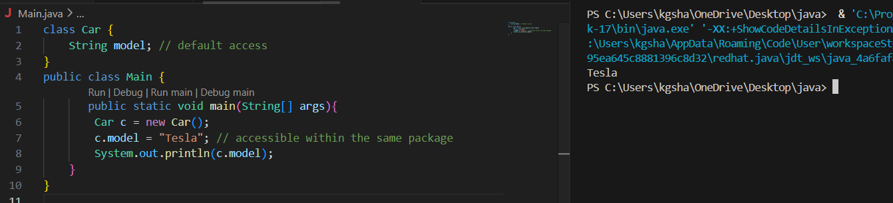
//Private Access Modifier
class Person {
// private variable
private String name;
public void setName(String name) {
this.name = name; // accessible within class
}
public String getName() {
return name;
}
}
public class Geeks {
public static void main(String[] args)
{
Person p = new Person();
p.setName("Shakthi shree");
System.out.println(p.getName());
}
}
Output
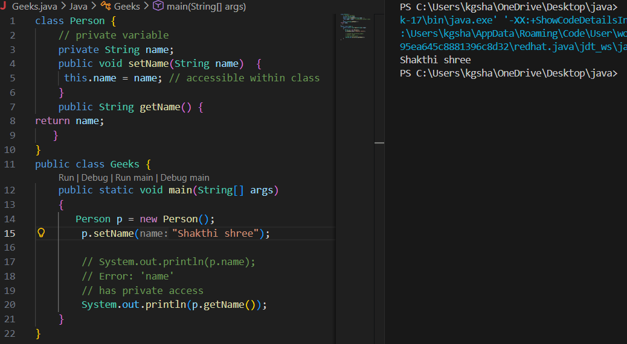
//Protected Access Modifier
class Vehicle {
protected int speed; // protected member
}
class Bike extends Vehicle {
void setSpeed(int s)
{
speed = s; // accessible in subclass
}
int getSpeed()
{
return speed; // accessible in subclass
}
}
public class Main {
public static void main(String[] args){
Bike b = new Bike();
b.setSpeed(100);
System.out.println("Access via subclass method: "+ b.getSpeed());
Vehicle v = new Vehicle();
System.out.println(v.speed);
}
}
Output
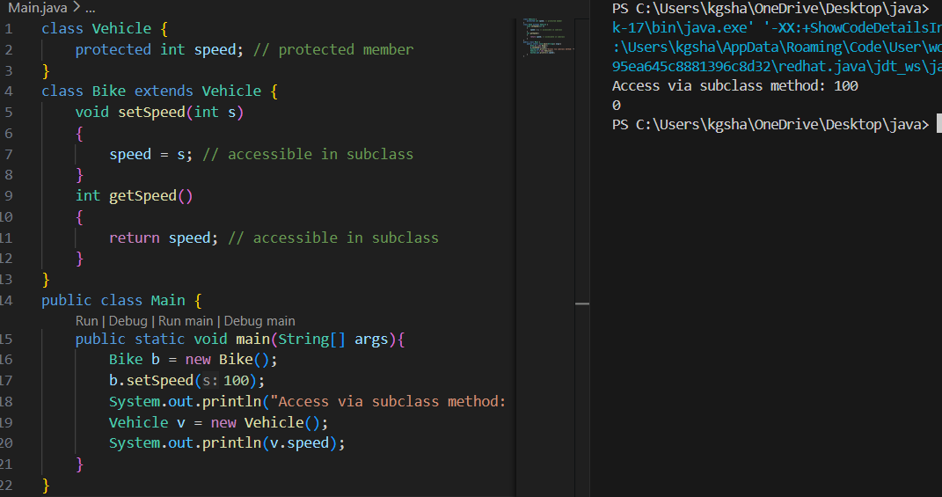
//Public Access Modifier
class MathUtils {
public static int add(int a, int b) {
return a + b;
}
}
public class Main {
public static void main(String[] args) {
System.out.println(MathUtils.add(8, 10)); // accessible anywhere
}
}
Output
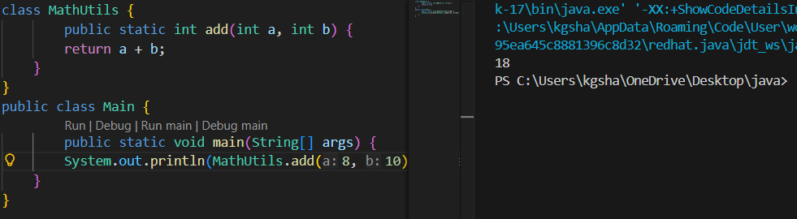
POST LAB EXERCISE
  - Write a Java program to implement Default access modifier which has a default class within the same package and a default class from a different package.
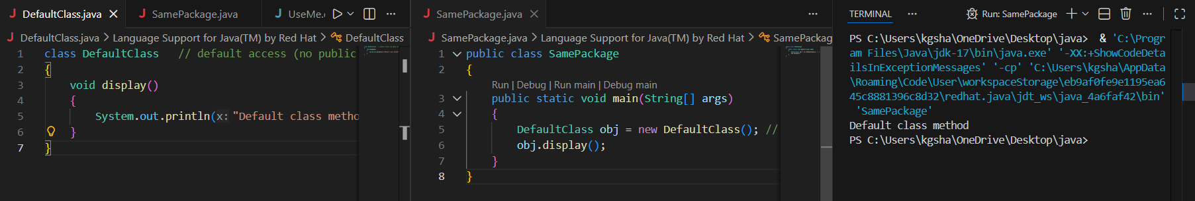
  - Which access modifier provides the highest level of access?
- Public provides the highest level of accessibility.
- It can be accessed within the class, within the package, and outside the package.
- It is also accessible through inheritance in other packages.
- Public members are visible from anywhere in the program.

ASSESSMENT

Description | Max Marks | Marks Awarded
Pre Lab Exercise | 5
In Lab Exercise | 10
Post Lab Exercise | 5
Viva | 10
Total | 30
Faculty Signature
Experiment Number :11 Date: 26.02.2026

Implementation of multiple inheritance in Java using Interface

Aim:
Write a Java program to implement multiple inheritance using Interface.

PRE LAB EXERCISE
QUESTIONS
- Why Java does not support multiple inheritance using classes like that of C?
- Java does not support multiple inheritance with classes to avoid ambiguity.
- It creates the Diamond Problem, where the compiler cannot decide which parent class method to execute.
- This leads to code complexity and maintenance issues.
- Java provides multiple inheritance through interfaces as a safer alternative.

- What is the primary purpose of an interface in Java?
- To store data using instance variables
- To define a contract of methods a class must implement
- To allow creation of objects
- To improve runtime performance
Correct answer: B. To define a contract of methods a class must implement
- An interface specifies method declarations without implementation.
- A class that implements the interface must define all the methods.
- It is used to achieve abstraction and multiple inheritance.
- It ensures standardization and loose coupling between classes.

IN LAB EXERCISE
Objective
To demonstrate how an interface in Java defines constants and abstract methods, which are implemented by a class.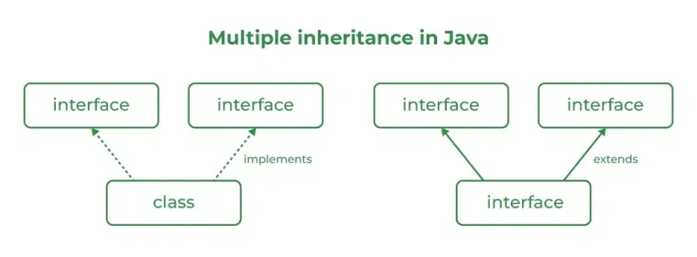

Source Code
import java.io.*;
// Add interface
interface Add{
int add(int a,int b);
}
// Sub interface
interface Sub{
int sub(int a,int b);
}
// Calculator class implementing Add and Sub
class Cal implements Add , Sub
{
// Method to add two numbers
public int add(int a,int b){
return a+b;
}
// Method to sub two numbers
public int sub(int a,int b){
return a-b;
}
}
class Example{
// Main Method
public static void main (String[] args){

// instance of Cal class
Cal x = new Cal();
System.out.println("Addition : " + x.add(2,1));
System.out.println("Substraction : " + x.sub(2,1));
}
}

Outputs
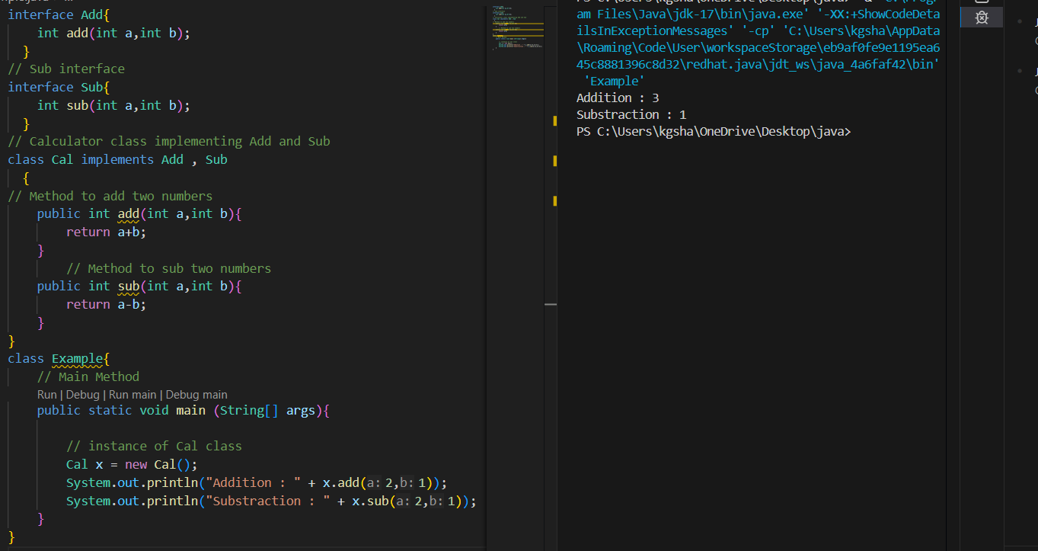
POST LAB EXERCISE
  - Can a functional interface extend another interface?
- Yes, a functional interface can extend another interface in Java.
- The total number of abstract methods must be only one, including the inherited method.
- It can contain any number of default methods.
- It can contain static methods.
- If it has more than one abstract method, then it is not a functional interface.

  - Which feature was introduced in interfaces starting from Java 8?
- Constructors
- Private methods
- Default and static methods
- Final classes
- Correct answer is C. Default and static methods.
- Default methods allow method implementation inside an interface.
- Static methods can be called using the interface name.
- Constructors are not allowed in interfaces.
- Private methods were introduced in Java 9.
- Interfaces cannot be final.

ASSESSMENT

Description | Max Marks | Marks Awarded
Pre Lab Exercise | 5
In Lab Exercise | 10
Post Lab Exercise | 5
Viva | 10
Total | 30
Faculty Signature

Experiment Number : 12 Date: 26.02.2026

Implementation of exception handling in Java
Aim:
Write a java program to implement exception handling.

PRE LAB EXERCISE
QUESTIONS
- What is exception handling in Java?
- Exception handling in Java is a mechanism used to handle runtime errors.
- It prevents the program from terminating abnormally.
- It allows the normal flow of the program to continue.
- It is done using keywords such as try, catch, finally, throw, and throws.
- It helps in maintaining program stability and readability.

- What is the purpose of using try-catch blocks in exception handling?
- The try block is used to write the code that may generate an exception.
- The catch block is used to handle the exception that occurs in the try block.
- It prevents the program from crashing when an error occurs.
- It allows the programmer to display an error message or take corrective action.
- It ensures the smooth execution of the remaining program.

IN LAB EXERCISE
Objective
To understand and implement exception handling through try-catch and finally blocks.
Source Code
import java.util.InputMismatchException;
import java.util.Scanner;
public class ExceptionHandlingExample {
public static void main(String[] args) {
Scanner scanner = new Scanner(System.in);
try {
System.out.print("Enter an integer: ");
int num = scanner.nextInt();
int result = 10 / num;
System.out.println("Result: " + result);
} catch (InputMismatchException e) {
System.out.println("Invalid input! Please enter an integer.");
} catch (ArithmeticException e) {
System.out.println("Cannot divide by zero!");
} finally {
scanner.close();
System.out.println("Program execution completed.");
} }
}
Outputs
Output 1 (Valid Input - Non-zero Integer):
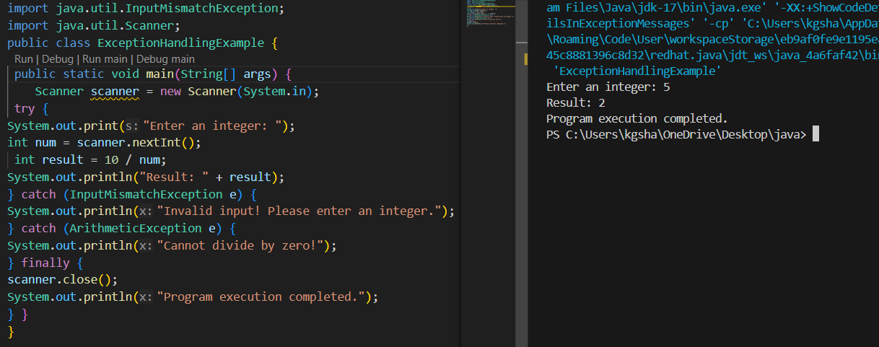
Output 2 (Valid Input - Zero):
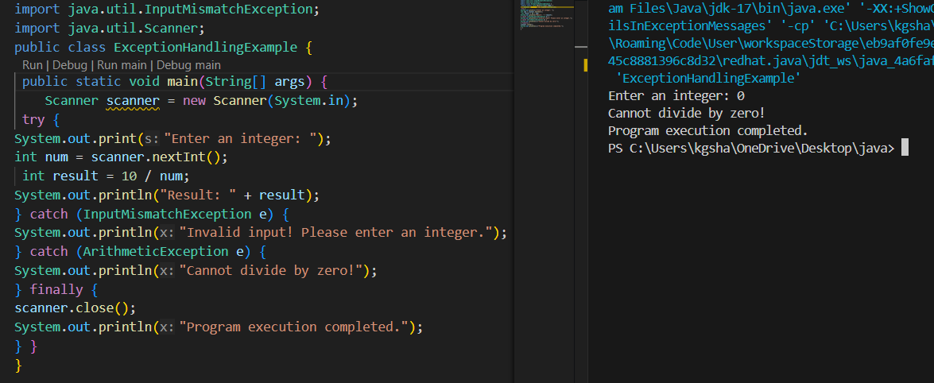
Output 3 (Invalid Input - Non-integer):
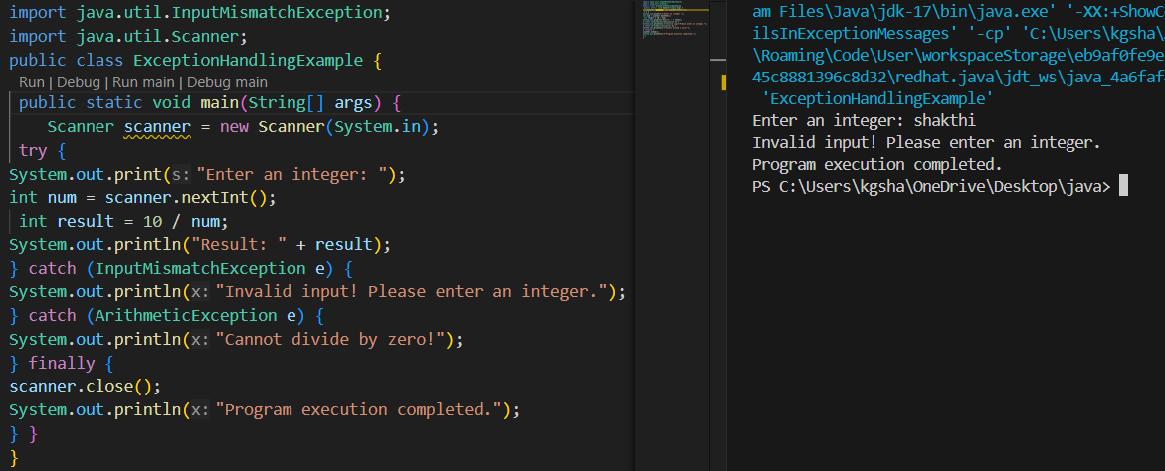

POST LAB EXERCISE
1. What is the purpose of the Scanner object in the Java program?
- The Scanner object in Java is used to take input from the user.
- It reads different types of data such as int, float, double, and String.
- It is commonly used to read input from the keyboard using System.in.
- It converts the input into the required data type.
- It makes user interaction possible in a program.
2. What exceptions are expected to be thrown in the code within the try block? Why?
- InputMismatchException may occur if the user enters a value of the wrong data type.
- ArithmeticException may occur if a number is divided by zero.
- NumberFormatException may occur when converting a non numeric string into a number.
- ArrayIndexOutOfBoundsException may occur if an invalid array index is accessed.
- These exceptions occur because of invalid input, illegal mathematical operations, or accessing data beyond its limit.

ASSESSMENT

Description | Max Marks | Marks Awarded
Pre Lab Exercise | 5
In Lab Exercise | 10
Post Lab Exercise | 5
Viva | 10
Total | 30
Faculty Signature

Experiment Number : 13 Date: 26.02.2026

Implementation of User-defined Exception in Java

Aim:
Write a java program to implement User-defined Exception.

PRE LAB EXERCISE
QUESTIONS
2. What are the two types of custom exceptions in Java?
1. What is Java custom exception?
- A custom exception in Java is a user-defined exception.
- It is created by the programmer to handle specific application errors.
- It is defined by extending the Exception class or RuntimeException class.
- It is used when the built-in exceptions are not suitable for a particular situation.
- It helps in creating meaningful and application-specific error messages.
2. What are the two types of custom exceptions in Java?
- Checked custom exception
  - Created by extending the Exception class.
  - It is checked at compile time.
- Unchecked custom exception
  - Created by extending the RuntimeException class.
  - It is checked at runtime.

IN LAB EXERCISE
Objective
To understand and implement Checked and Unchecked custom exceptions.
Source Code
Ex 1: // Custom Checked Exception
class InvalidAgeException extends Exception {
public InvalidAgeException(String m) {
super(m);
}
}
// Using the Custom Exception
public class AgeCheck{
public static void validate(int age)
throws InvalidAgeException {
if (age < 18) {
throw new InvalidAgeException("Age must be 18 or above.");
}
System.out.println("Valid age: " + age);
}
public static void main(String[] args) {
try {
validate(12);
} catch (InvalidAgeException e) {
System.out.println("Caught Exception: " + e.getMessage());
}
}
}

Output 1 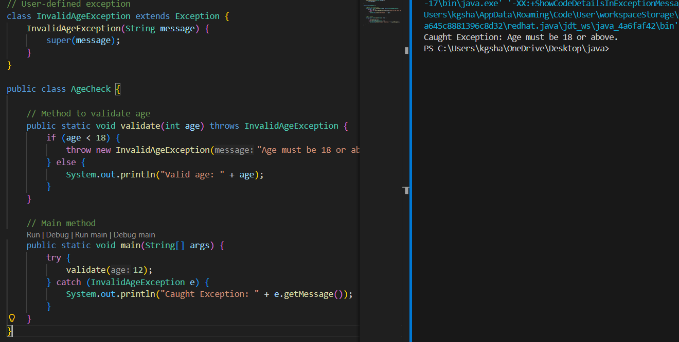
Ex 2: // Custom Unchecked Exception
class DivideByZeroException extends RuntimeException {
public DivideByZeroException(String m) {
super(m);
}
}
// Using the Custom Exception
public class TestSample {
public static void divide(int a, int b) {
if (b == 0) {
throw new DivideByZeroException("Division by zero is not allowed.");
}
System.out.println("Result: " + (a / b));
}
public static void main(String[] args) {
try {
divide(10, 0);
} catch (DivideByZeroException e) {
System.out.println("Caught Exception: " + e.getMessage());
}
}
}

Output 2
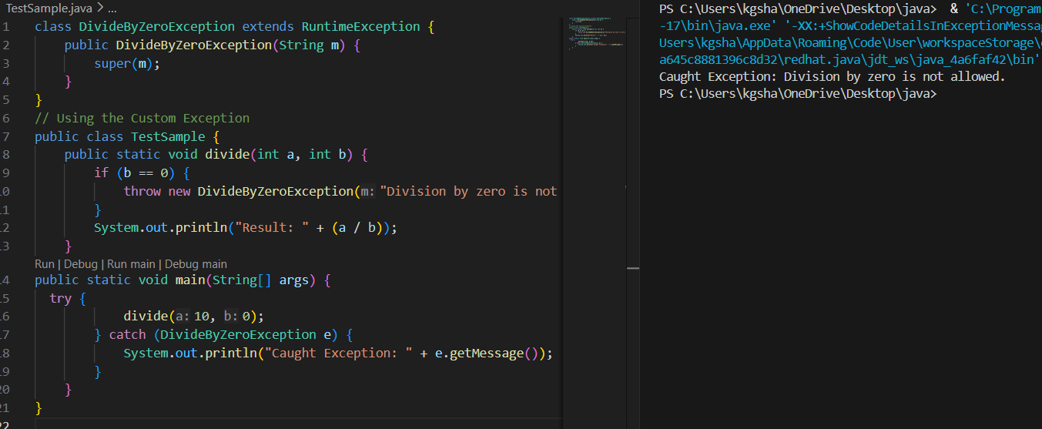
POST LAB EXERCISE
- What is required to create a custom exception in Java?
- Extend the Object class
- Extend the Throwable class
- Extend Exception or RuntimeException
- Implement the Serializable interface
Correct answer: C. Extend Exception or RuntimeException
- A custom exception class must inherit from Exception or RuntimeException.
- Extending Exception creates a checked exception.
- Extending RuntimeException creates an unchecked exception.
- This allows the exception to work with Java’s exception handling mechanism.

- List some use cases for the checked and unchecked exceptions.
Checked exceptions – use cases:
- File operations such as reading or writing a file.
- Database connectivity and SQL operations.
- Network communication.
- Situations where the error can be handled and recovery is possible.
Unchecked exceptions – use cases:
- Dividing a number by zero.
- Accessing an array with an invalid index.
- Using a null reference.
- Logical programming errors that should be corrected in the code.

ASSESSMENT

Description | Max Marks | Marks Awarded
Pre Lab Exercise | 5
In Lab Exercise | 10
Post Lab Exercise | 5
Viva | 10
Total | 30
Faculty Signature

